|  |
| --- |
| Victoria State Accident Dashboard Executive Summary |
| Augustine Kim (s5125270), Kai Chun Yu (s5309764), Ann Tapiador (s5314834)2810ICT/7810ICT Software TechnologiesOctober 8, 2023 |

# Abstract

Data from the Victoria State Accident Dashboard shows that the number of accidents in the state of Victoria has been declining within the 5-year period of January 2014 to December 2019, influenced by the decline in non alcohol-related accidents.

Alcohol-related accidents are significantly lower in number but remains generally the same within the 5-year period. Nonetheless, we see that the number of Fatal and Serious Injuries due to alcohol has significantly declined. Note however, that based on the 2018 data, there is still a higher chance of getting seriously injured in an accident where alcohol is involved than when there is none. Accidents occurring with alcohol involved are also more likely to collide with a fixed object.

Most of the accidents in the state of Victoria occurred in the Metropolitan North West Region and Metropolitan South East Region but are also on a downward trend.

Given the findings, we can see that efforts to lower the number of accidents within the given period was effective. It was also successful in lowering fatal and serious injuries caused by alcohol related accidents. Note however, that we need to further understand the drivers for the high number of non-alcohol related accidents, as this accounts for the bigger percentage of the overall count.

# Introduction

The purpose of this report is to demonstrate how the system can aid in the analysis of the accident database from the state of Victoria, that will allow for improved road safety and alleviate corresponding social and economic costs brought about by road trauma. This will allow the Victorian government to measure if the polices that were set to improve road safety are effective, based on actual performance versus identified goals or metrics (e.g., lowering the number of alcohol-related accidents by a set percentage versus previous year).

As the database is robust, the system can still be improved to include details such as exact location, road type, road geometry, driver’s age, type of road user, light condition, etc. However, for the purpose of this demonstration, details here will focus on date, hour of the day, the impact of alcohol, type of accident, severity, and regional location, which should be sufficient to address the main 5 functionalities required by client.

The system can run on Python, which can be downloaded for free, on MAC and Windows PC/laptops. It is flexible enough to show status and trends based on user-selected parameters (e.g., by period or by type of accident etc.).

The available data covers accidents that occurred between July 1, 2013 to March 21, 2019. Given possible backlogs in filing of reports, the analysis will not include the last 3 months covered by the data (January to March 2019). Instead, it will focus on the 12-month period within 2018 (January to December). Data from previous years will also be included to serve as a benchmark, to better visualize the trajectory, and get an indication of whether there were improvements in lessening the number of accidents for the said year.

# **Analysis 1 – Information on all accidents based on selected period**

The system can display information on all accidents based on the user-selected period. The screenshot below shows a snippet all accidents that occurred within 2018 together with other related information considered in this simulation, i.e., time, alcohol relation, accident type, severity, and region name. In the system, the succeeding rows can be viewed by hovering the mouse over the table and scrolling down.

This type of presentation is useful for drilling down the analysis to individual cases. The example below shows accidents from March 19 to 21, 2019. Here we see that the case with Accident No T20190005193 is a non alcohol-related accident, which occurred March 19, 2019 at the Northern Region. The accident occurred 7:10 in the morning, where the driver struck an animal, leading to a serious injury.

# **Analysis 2 – Average number of accidents in each hour of the day based on selected period.**

Figure 2A shows that most of the accidents in 2018 happened between 3pm to 6pm, followed by 8am to 9am. This trend remains the same when looking at the 5-year period on Figure 2B.

**Figure 2A: Average number of accidents in each hour of the day for 2018**

**Figure 2B: Average number of accidents in each hour of the day within the 5-year period (2014 to 2018)**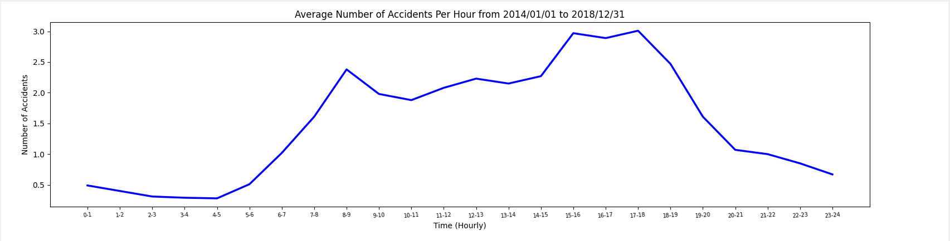

# **Analysis 3 – All accidents caused by an accident type that contains a keyword (e.g., collision, pedestrian), based on selected period.**

The system can also display information on all accidents based on a keyword and user-selected period. The screenshot below shows a snippet all accidents that occurred within 2018, with the keyword “Fall”.

Simliar to the first analysis, this type of presentation is useful for drilling down to individual cases. For example, here we try see all accidents within March 2019 with the keyword “Struck animal”. We see that there were 2 incidents, one from Northern Region, and another from the Western region. Both occurred in the morning and were not alcohol related, where one accident caused serious injury.

# **Analysis 4 – Impact of alcohol in accidents such as trends over time and accident types involving alcohol.**

To get a better understanding on the impact of alcohol on accidents, we compare alcohol related accidents against non alcohol-related accidents, focusing on Accident Type, Severity and Regional Location. However, for this section of the analysis, we will only discuss Accident Type and Severity as the 5th analysis will cover accidents by region, which will also touch on the impact of alcohol in the area.

Unlike non alcohol-related accidents (Figure 4A) where incidences are mostly due to collision with a vehicle, Figure 4B demonstrates that accidents occurring due to alcohol are more likely to collide with a fixed object, while collision with a vehicle only comes second.

The number of alcohol related accidents is significantly lower than non alcohol related accidents but the number of alcohol related accidents remain generally same within the 5-year period of 2014 to 2015 (See Figure 4D). On the other hand, non alcohol related accidents show a decline in trend (See Figure 4C).

**Figure 4A: Non Alcohol Related Accidents by Accident Type for 2018**

**Figure 4B: Alcohol Related Accidents by Accident Type for 2018**

**Figure 4C: Non Alcohol Related Accidents by Accident Type within the 5-year period (2014 to 2018)**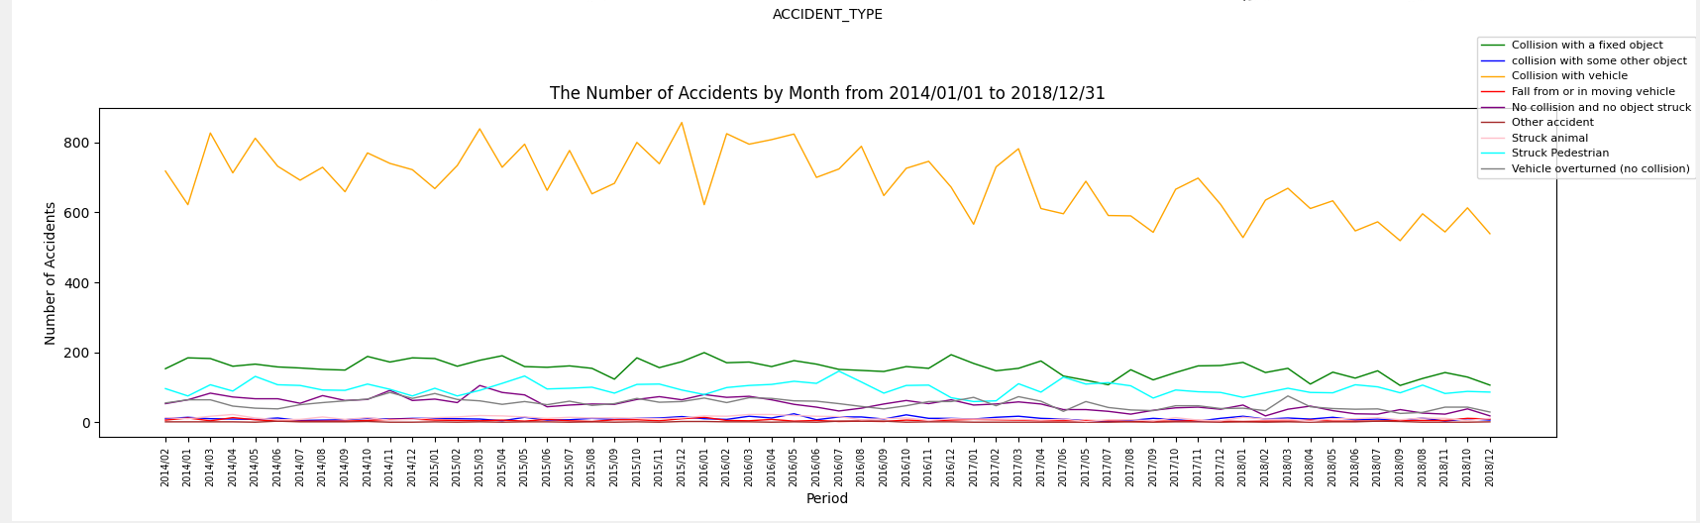

**Figure 4D: Alcohol Related Accidents by Accident Type within the 5-year period (2014 to 2018)**

Figure 4E shows that most non alcohol related accidents are not serious nor fatal. On the other hand, Figure 4F demonstrates while the biggest effect of alcohol related accidents will still be not serious nor fatal, there’s a higher chance of getting seriously injured than when there is no alcohol involved.

On the upside, Figure 4H demonstrates a significant decline in serious and fatal injuries for alcohol related accidents within the 5 year period of 2014 to 2018.

**Figure 4E: Non Alcohol Related Accidents by Severity for 2018**

**

**Figure 4G: Non Alcohol Related Accidents by Severity within the 5-year period (2014 to 2018)**

**Figure 4H: Alcohol Related Accidents by Severity within the 5-year period (2014 to 2018)**

# **Analysis 5 – Number of accidents for each region in the state of Victoria based on selected period.**

Figure 5A shows the total number accidents by region within 2018, with most of the accidents occurring at Metropolitan North West Region, followed by Metropolitan South East Region. Figure 5B further filters the data to only alcohol-related accidents. Here we can see that the number of alcohol related accidents is significantly lower than the overall number, with Metropolitan South East Region having a higher number of alcohol-related accidents versus Metropolitan North West Region.

**Figure 5A: Total Accidents by Region for 2018**

**Figure 5B: Alcohol-Related Accidents by Region for 2018**

Figure 5C shows that accidents for both regions are consistently significantly high all throughout the year, with the highest occurrence happening in the month of March. Further filtering it down to Alcohol Related accidents on Figure 5D, we see that for most regions, these occurrences mostly happen in the months of March, July, and November. However, looking at Figure 5E, we can see a general decline in the number of accidents within the 5-year period. While alcohol-related accidents show no improvement within the same 5-year period, the number is still relatively low, at less than 20 accidents per month, except for December 2015 in the Metropolitan South East Region which reached beyond 30 accidents.

**Figure 5D: Alcohol-Related Accidents by Region for the Months of 2018**

**Figure 5E: Total Accidents by Region within the 5-year period (2014 to 2018)**



